Shoe Activity
Paragraph 1
Carefully inspect the shoe you collected. Look at all aspects of it. What type of person might this shoe belong to? Think of the characteristics of that person. Age, gender, interests, personality, qualities, introversion/extroversion, humility, etc. What evidence do you have to back this up? Explain what you found (based on the type of shoe as well as the aspects of the shoe) that proves that these characteristics!

Paragraph 2
How might your perspective as an individual have altered the description of the person you selected or altered the evidence you used to back that up? Do you think your knowledge of, or preferences toward shoes may have changed the explanation you gave or the evidence you collected? Why or why not?

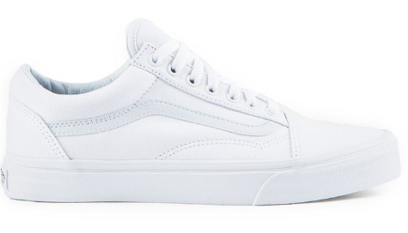
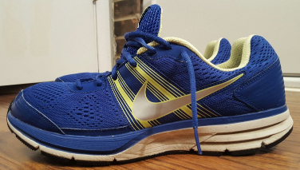
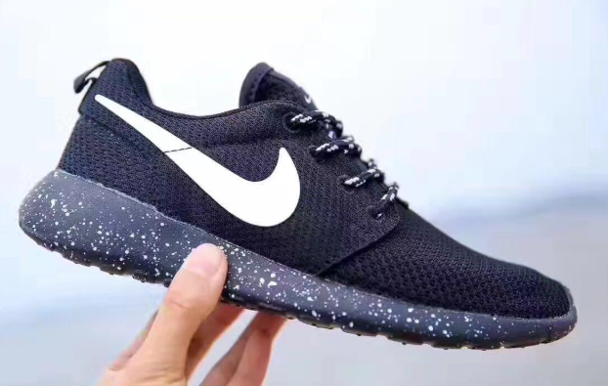
Make-up assignment: Pick one these shoes. Do the above paragraphs on notebook paper and return to me next class.

